**PART II: RELATIONAL MODEL**

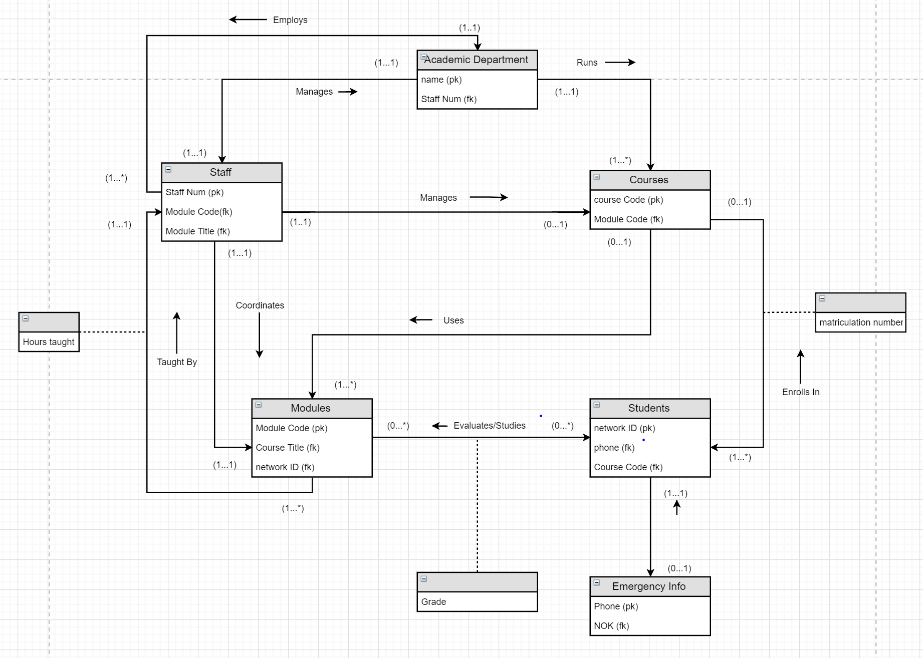

**B. Relations/Attributes**

|  |  |
| --- | --- |
| Academic Department (name, Fax Number, location, phone number)  Primary key (name)  Foreign key StaffNo references Staff(Staff No) | Staff (Staff Num, network ID, First name, Last name, Phone Ext, Office Num, Sex, Salary, Post, qualifications, Address)  Primary Key (Staff Num)  Foreign Key Module Code references Modules (module code)  Foreign Key Module title references Modules (Module title) |
| Modules (Module code, module title, start date, end date, textbooks, assessment Scheme)  Primary Key (Module Code)  Foreign Key Course Title references Courses(course title)  Foreign network ID references Students(network ID) | Courses (Course Code, course Title, prereqs, duration)  Primary key Course Code  Foreign key Module Code references Modules (module code) |
| Students (network ID, last name, first name, address, DOB, Sex, Financial Loans)  Primary Key network ID  Foreign key phone referenced from emergency info(phone)  Foreign key module course referenced from modules(module code) | Emergency Info (phone, address, full name, NOK)  Primary Key Phone  Foreign Key NOK (This is not right, im just keeping it here so I can fix it tomorrow.) |

**Common Comments**

**Justin Pulido**

* Difficulties that I faced during this portion of the project was seeing which relationship attributes were used for the foreign keys and which made sense to be used for specific portions of it. This was resolved by asking my teammate for help and he was able to review my portions and let me know his input on what to change and help me see my errors so I can fix them.
* Likes about this project is being able to grasp the concepts more and being able to understand more about how foreign keys interact with different entities. Dislikes about this part is the second portion is a little vague to me as I feel I am not fully grasping the second part of the table even with the help I am receiving.
* The most challenging aspect of this part of the project was the relationship/attributes portion. Some of the material I was constantly looking over and it was difficult to grasp the concept. Once I did though it did make sense, but I am still not fully understanding it and my teammate is helping a lot with this.
* Suggestions to help improve this portion of the project is to have students show a rough sketch of the ER with the PK and FK’s to see if they are on the right track with making sure they are understanding the uses of the FK’s and PK’s properly.

**Personal Comments**

E. Justin Pulido

* I contributed to the first portion of the Entity Relationship with the PK’s and FK’s and filled out some of the table for the Relationship/Attributes table on the second page.
* My partner helped in reviewing my work to ensure the attributes and the ER diagram was correct. Also assisted me in helping me understand more of the FK’s as I was a little confused and when I asked him he was able to assist me on this portion of it.